A Philosophy of Institutional
Clinical Informatics
Governance, distributed clinical intelligence, and the partnership between informatics and information technology
Justin Halls, MD
Personal professional philosophy • Draft One • October 2026
Core thesis
Healthcare technology is not merely a technical enterprise. It is a sociotechnical system that requires technical intelligence, clinical-informatics intelligence, and distributed domain expertise. Governance is the mechanism that brings those forms of intelligence together at the right level of decision-making.

1. Informatics is not synonymous with IT
Modern healthcare depends on information technology, but the effective use of technology in clinical care is not principally an infrastructure problem. Clinical systems operate inside complex human organizations, embedded in workflows, professional cultures, regulatory constraints, clinical knowledge, and patient-care processes. A technically sound system can therefore be clinically ineffective—or unsafe—if it is poorly matched to the work it is intended to support.
This distinction creates a necessary partnership between central information technology and clinical informatics. Neither should be subordinate in intellectual function to the other, and neither can substitute for the other.

Information technology
Central IT is responsible for the technical enterprise: infrastructure, applications, architecture, cybersecurity, integration, reliability, technical standards, implementation capacity, vendor relationships, and the sustainable operation of the digital environment. Its central question is: Can this be built, integrated, secured, operated, and supported reliably?

Clinical informatics
Clinical informatics addresses how information and technology should represent, support, and improve clinical care. Its work includes clinical workflow, human-computer interaction, decision support, information needs, usability, implementation, change management, evaluation, and the clinical consequences of digital design. Its central question is: How should information and technology interact with clinicians, patients, evidence, and workflow to improve care?

Clinical domain expertise
Clinical informatics is itself insufficient without distributed subject-matter expertise. No central informatics group can possess deep expertise in every clinical domain. The correct design of transfusion decision support, oncology workflows, medication safety, critical-care documentation, radiology systems, nursing workflows, or surgical care requires people who understand those domains in depth.
The institutional model must therefore deliberately combine three forms of intelligence: technical intelligence, informatics intelligence, and domain intelligence. Good governance makes their interaction routine rather than accidental.

2. A hub-and-spoke model for clinical informatics
The enterprise needs a central clinical-informatics hub with responsibility for institutional strategy, standards, coordination, prioritization, and stewardship. But centralized expertise must not become centralized omniscience. The hub should be connected to meaningful informatics representation across the clinical enterprise.
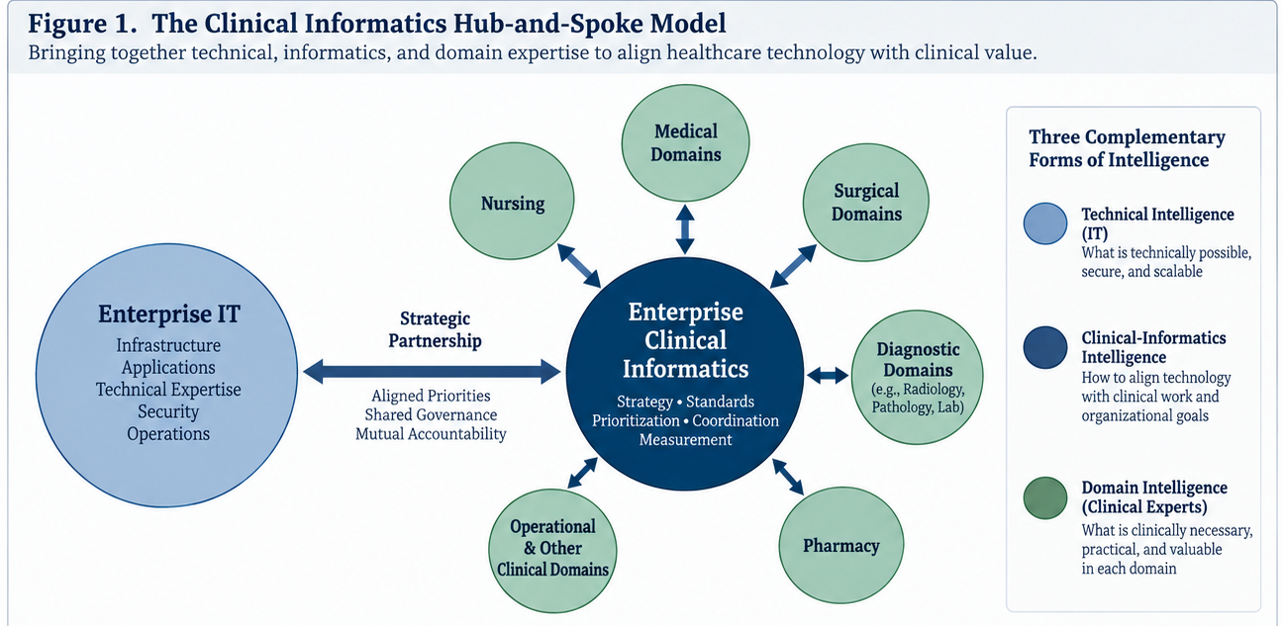
Figure 1. Clinical informatics as an enterprise hub: a distinct partner to IT and a bidirectional connection to distributed clinical domain expertise.
The spokes should correspond to major clinical and operational domains and should be populated by people who understand both their local work and the principles of informatics. Their purpose is not merely to represent departmental interests. They are a mechanism for translating distributed clinical intelligence into enterprise decisions and for translating enterprise decisions back into local practice.
Information should move in both directions. Frontline needs, safety concerns, workflow failures, and opportunities should move toward the hub. Enterprise standards, constraints, priorities, and shared solutions should move outward. The system should make it easier for local expertise to influence enterprise technology without allowing every domain to become an independent technology organization.

3. Governance is an operating system, not an org chart
Governance is successful when it creates a predictable pathway from clinical need to institutional action. It should answer practical questions: Where does an idea enter? Who evaluates it? Is the issue local or enterprise-wide? Who has decision rights? Which expertise is required? How is work prioritized against competing needs? Who owns implementation? How is the result measured? What happens when stakeholders disagree?
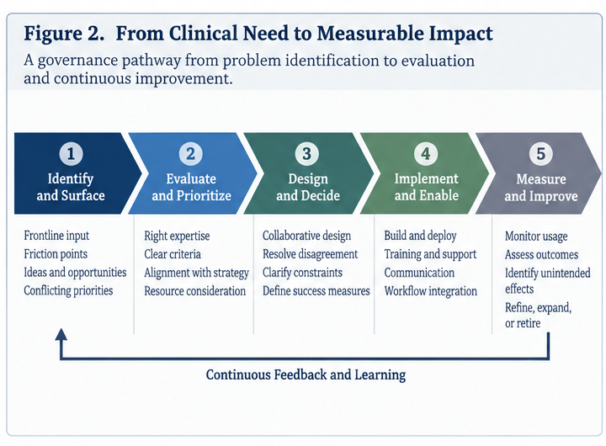
Figure 2. A governance pathway from surfaced clinical need through prioritization, design, implementation, measurement, and continuous feedback.
This requires more than committees. It requires explicit pathways, decision rights, escalation mechanisms, feedback loops, and lifecycle ownership. A closed ticket is not equivalent to a solved problem. Implementation should begin a period of measurement, not end institutional attention.

Conflict should be surfaced, not hidden
Healthy governance does not eliminate conflict. Clinical priorities, technical constraints, resource limitations, safety considerations, and enterprise standardization will sometimes point in different directions. A mature system makes those tensions visible and navigable.
A legitimate governance outcome may be a change in the system, a compromise, a deferred decision, or a well-explained constraint. Even when the desired change cannot be made, the issue should receive a credible hearing, an accountable disposition, and a comprehensible explanation. Unexplained constraints create narratives; transparent constraints create understanding.
I think of these as friction points: places where clinical work and the digital or organizational environment are poorly aligned. A healthy organization should want to discover more of them, not fewer. Their visibility is evidence that the feedback system is working.

4. Clinical decision support is a governance discipline
Clinical decision support illustrates why this model matters. Effective CDS requires the right clinical content, the right recipient, the right intervention format, the right channel, and the right point in workflow. Those decisions cannot be made well by technical expertise alone, nor by domain expertise alone.
The goal should not be fewer decision-support capabilities. It should be more useful decision support with less unnecessary interruption. Better targeting, contextual specificity, passive or embedded support when appropriate, deliberate use of interruptive alerts, and active retirement or redesign of poorly performing interventions can allow the CDS portfolio to grow while clinician-facing noise falls.
Every significant CDS intervention should have an owner, a clinical rationale, an intended outcome, a defined audience and workflow, and a lifecycle that includes post-implementation evaluation. Clinical content should not become permanent merely because it once passed governance.

5. Cross-cutting capabilities need enterprise stewardship
Some informatics capabilities do not fit naturally within any single clinical spoke. Clinical decision support, artificial intelligence, data and analytics, interoperability, patient safety, knowledge management, and aspects of digital innovation cut horizontally across the enterprise.
These capabilities require enterprise stewardship and common standards while remaining connected to domain expertise. Artificial intelligence makes this especially important: model performance, workflow integration, clinical appropriateness, safety, monitoring, and accountability cross traditional organizational boundaries. The solution is not to place every question inside either IT or a clinical department, but to create governance capable of spanning both.

6. Aims of the philosophy
These are not institution-specific performance targets. They are directional aims that should be translated locally into specific, measurable, achievable, relevant, and time-bound goals.

Increase signal while reducing noise
Expand the reach and sophistication of useful CDS while reducing unnecessary clinician-facing interruption through better targeting, workflow integration, specificity, and lifecycle management.

Surface and navigate friction
Create trusted mechanisms that systematically identify clinical-technology friction points, bring the appropriate expertise to them, provide accountable disposition, and explain constraints when resolution is not possible.

Shorten the distance from clinical need to institutional action
Make it easier for legitimate frontline needs to reach people with the authority and expertise to evaluate them, and make the path from identification to disposition visible to the people who raised the issue.

Measure after implementation
Treat deployment as the beginning of evaluation. Measure adoption, workflow effects, intended outcomes, unintended consequences, and continuing value; modify or retire interventions that do not perform as intended.

Measure value, not merely activity
Tickets closed, builds completed, alerts created, and projects delivered are measures of work. Informatics governance should increasingly measure what that work accomplished for patients, clinicians, operations, safety, quality, or organizational capability.

7. What this philosophy is ultimately trying to create
The desired institution is neither centrally controlled nor digitally fragmented. It has a strong technical core, a strong clinical-informatics function, and meaningful distributed clinical expertise. Authority is clear, but expertise can travel. Local problems can reach enterprise leadership; enterprise standards can reach local practice. Disagreement is surfaced rather than suppressed. Technology is evaluated by what it accomplishes in the clinical system, not merely by whether it functions.
The mature endpoint is a learning health system: an organization in which clinical experience, data, evidence, technology, and governance form a continuous improvement loop. The purpose of informatics governance is not to control technology. It is to make institutional intelligence actionable.
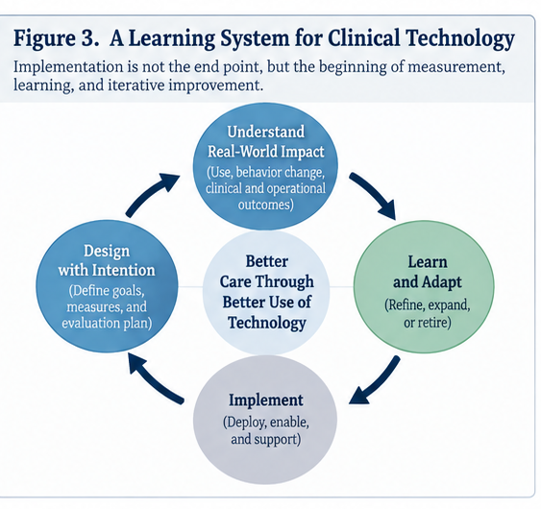
Figure 3. Implementation begins—not ends—the learning cycle: design intentionally, implement, measure real-world impact, and adapt.

Foundations and suggested reading
Sittig DF, Singh H. “A New Socio-technical Model for Studying Health Information Technology in Complex Adaptive Healthcare Systems.” Quality & Safety in Health Care. 2010.
Foundational framework for treating health IT as an interaction among technical infrastructure, clinical content, people, workflow, organizational structures, external rules, and measurement rather than as a purely technical system.
Gardner RM, Overhage JM, Steen EB, et al. “Core Content for the Subspecialty of Clinical Informatics.” Journal of the American Medical Informatics Association. 2009.
Defines clinical informatics as a discipline that combines patient-care knowledge with informatics to assess information needs, refine clinical processes, develop CDS, and lead or participate in the lifecycle of clinical information systems.
Kannry J, Fridsma D. “The Chief Clinical Informatics Officer (CCIO): AMIA Task Force Report on CCIO Knowledge, Education, and Skillset Requirements.” JAMIA. 2016.
Useful for understanding clinical-informatics leadership as a distinct organizational capability and for framing its relationship to traditional information-technology leadership.
Osheroff JA, et al. Clinical decision support “Five Rights” framework; see also related implementation literature.
A practical model for CDS: deliver the right information to the right person, in the right format, through the right channel, at the right point in workflow.
McCoy AB, et al. “A Pragmatic Guide to Establishing Clinical Decision Support Governance and Addressing Decision Support Fatigue: a Case Study.” Journal of the American Medical Informatics Association. 2019.
An especially useful operational example. University of Utah Health used multidisciplinary governance, analytics, active user feedback, and content review while continuing to add CDS and reducing overall clinician-facing alert/reminder burden by 53.8% over three years.
Office of the National Coordinator for Health Information Technology. 2025 SAFER Guides.
Current federal patient-safety guidance covering organizational responsibilities, system management, CPOE with decision support, clinician communication, and other areas. Particularly useful for connecting governance, accountability, monitoring, and EHR safety.
National Academy of Medicine. Learning Health System framework.
Provides the broader destination: science, informatics, incentives, and culture aligned for continuous improvement, with learning embedded in care delivery.

Selected online resources
American Medical Informatics Association: What Is Clinical Informatics?: https://amia.org/careers-certifications-informatics/clinical-informatics-subspecialty/clinical-informatics-fellowship/prospective-applicants/what-is-clinical-informatics
ONC: SAFER Guides: https://healthit.gov/clinical-quality-and-safety/safer-guides/
National Academy of Medicine: Learning Health System: https://nam.edu/our-work/programs/leadership-consortium/learning-health-system/

